**Name:** Cristina Pascua **Date:** 11/11

**Lab section:** Thursday

**Show your work!!!**

**Acquire**

Week: 9

Date: Feb. 29 Year: **2021** Data: <https://data.world/makeovermonday/2021w9>

**Source Article/Visualization:**

[Seats Held by Women in National Parliaments and Governments](https://ec.europa.eu/eurostat/databrowser/view/sdg_05_50/default/table?lang=en)  
Data Source: [Eurostat](https://ec.europa.eu/eurostat/databrowser/view/sdg_05_50/default/table?lang=en)

<https://www.makeovermonday.co.uk/data/>

**Represent**

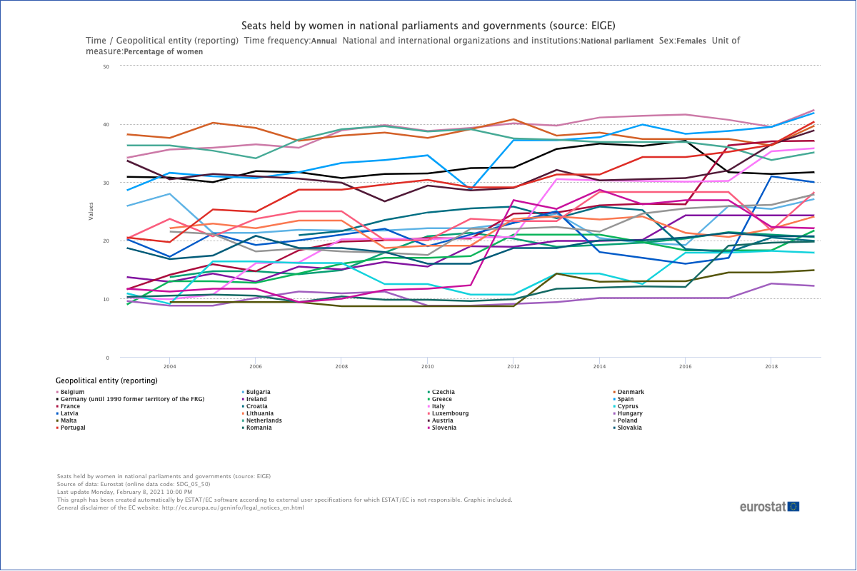

**Critique**

I think the original visualization looks confusing because of the number of different colored lines in the graph. Some of the colors are too close in color to tell which country it is representing. In addition, the colors in the legend are extremely small which further complicates the readability. Finally, it is hard to tell what insight they are showing.

This visualization falls under the data visualization category because it visualizes the quantitative data given in a schematic form. It uses the line graph method to show an overview of the data and attempts to use convergent thinking by representing each country with a line to reduce complexity.

**Mine**

I am attempting to answer the question “How does the number of women holding seats in government compare by each country and change throughout the years?” I answer this question by showing different visualizations of how the data changes throughout the years given.

**Filter**

**Show** (display, list, make it visible) the filtered data.

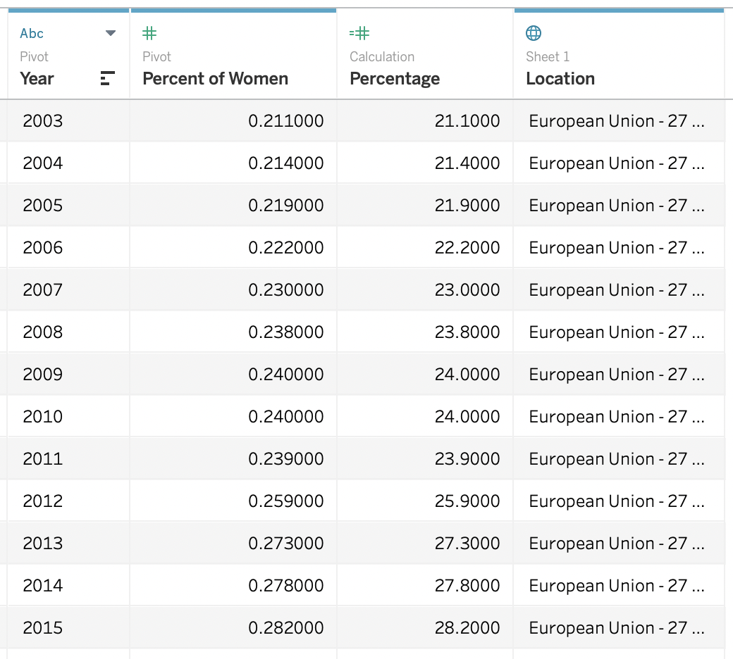

**Stakeholders**

My audience is the citizens and governments of European countries. I want this audience to be aware of the women holding seats in their country’s government throughout the years and how they compare to countries around them. I assumed that the rows that contained null values had no women in seats in government and decided to leave them out of the visualization. I used Tableau to create my visualization.

**What to submit:** This document in PDF format only (if you do not know how to do this, ask).

**Choose the best layout** for your makeover visualization: Portrait or Landscape, Remove the page of the layout that you DO NOT choose. No blank pages!

**NEW Sketch your Makeover**

In the space below, sketch out your ideas for refined visualization. You must use pen/pencil and paper to sketch out your idea, then take a photo of your sketch and include it in the space below.

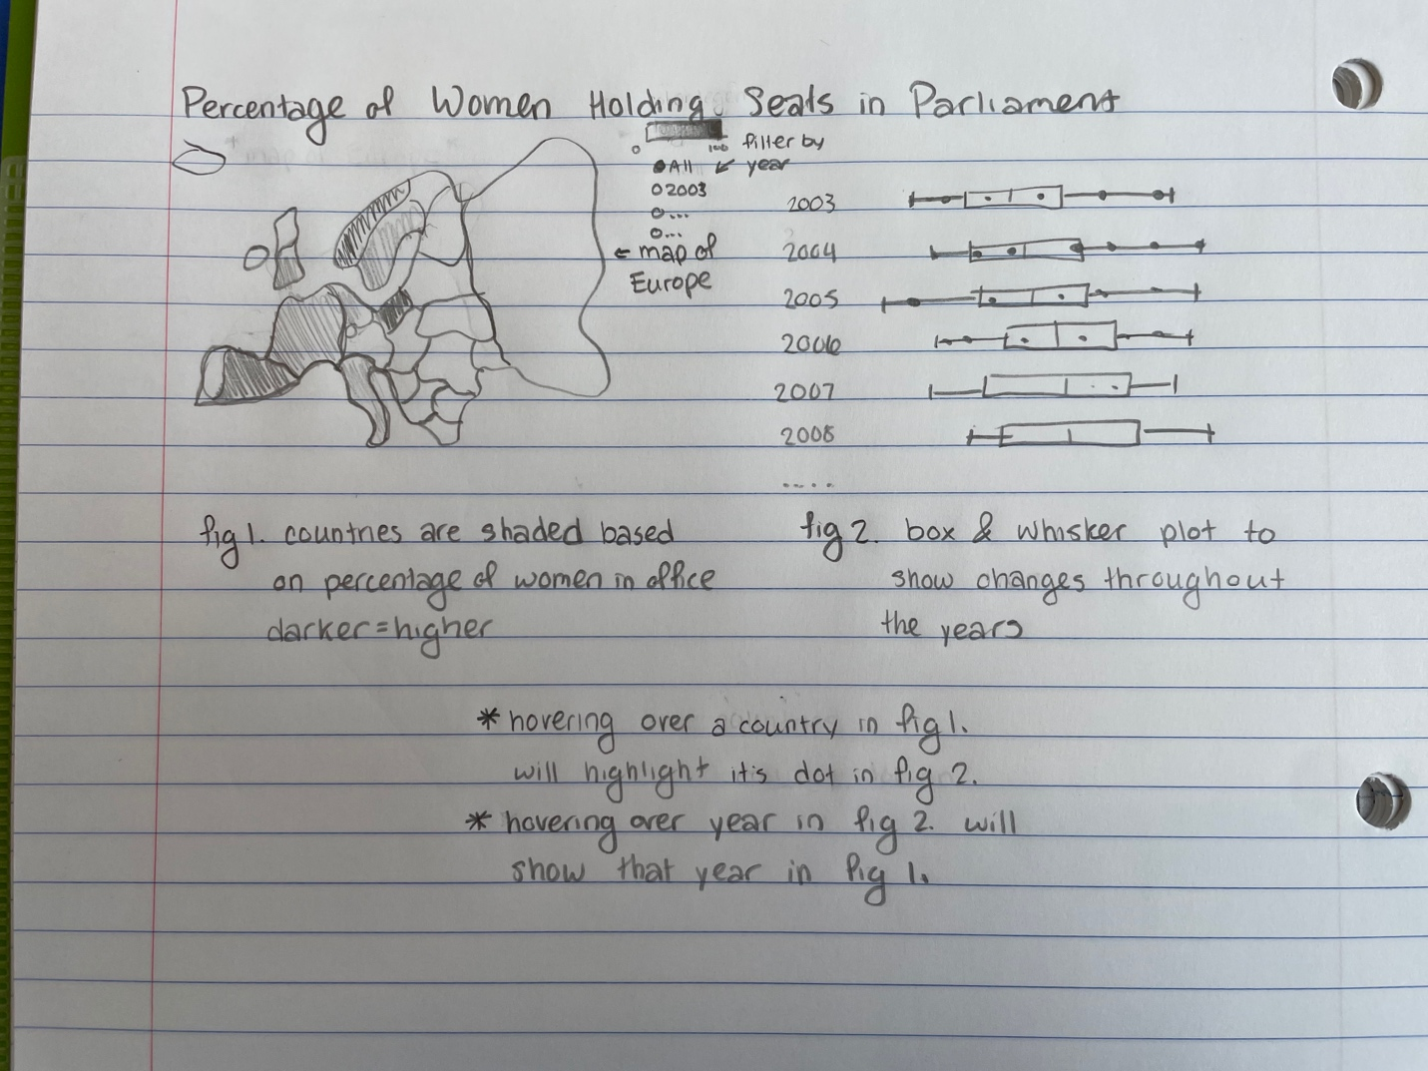

**Refine (Makeover – Landscape view)**



**Resources**

Data Visualization Checklist:

<http://stephanieevergreen.com/wp-content/uploads/2016/10/DataVizChecklist_May2016.pdf>

How to give constructive criticism:

<https://personalexcellence.co/blog/constructive-criticism/>

Sample Makeovers

<https://www.makeovermonday.co.uk/gallery/>

**Grading Rubric**

|  |  |  |  |
| --- | --- | --- | --- |
| **Excellent**  **(11-15 pts)** | **Good**  **(6 -10 pts)** | **Fair**  **(2-5 pts)** | **Needs Improvement (0 - 1 pt)** |
| Meets **ALL** or most of these: Makeover is esthetically pleasing (color, perception), best practices followed (insightful), Correct dataset downloaded; provided an interesting point of view of the data; critiqued previous makeover, critique is constructive (indicates one thing that is done well, and one thing that could be done differently, what will be done to improve the visualization), assumptions (more than one) are listed. | Meets **MOST** of these: Makeover is esthetically pleasing (color, perception), best practices followed (insightful), Correct dataset downloaded; provided an interesting point of view of the data; critiqued previous makeover, critique is constructive (indicates one thing that is done well, and one thing that could be done differently, what will be done to improve the visualization), assumptions (more than one) are listed. | Consistently meets **SOME** of these: Makeover is esthetically pleasing (color, perception), best practices followed (insightful), Correct dataset downloaded; provided an interesting point of view of the data; critiqued previous makeover, critique is constructive (indicates one thing that is done well, and one thing that could be done differently, what will be done to improve the visualization), assumptions (more than one) are listed. | Little to no evidence of the understanding of the data visualization process.  Lackluster makeover or no makeover.  Little effort. |
| Sketch included: hand-drawn [5 pts] | Sketch included but was generated by computer [2 pts] | No sketch included. [0 pts] |  |
| More advanced chart types used [5 pts] | More advanced chart types used, followed most best practices [3 pts] | Basic chat types used in the makeover [2 pts] | Little to no improvement in visual representation of the data [0 pts] |